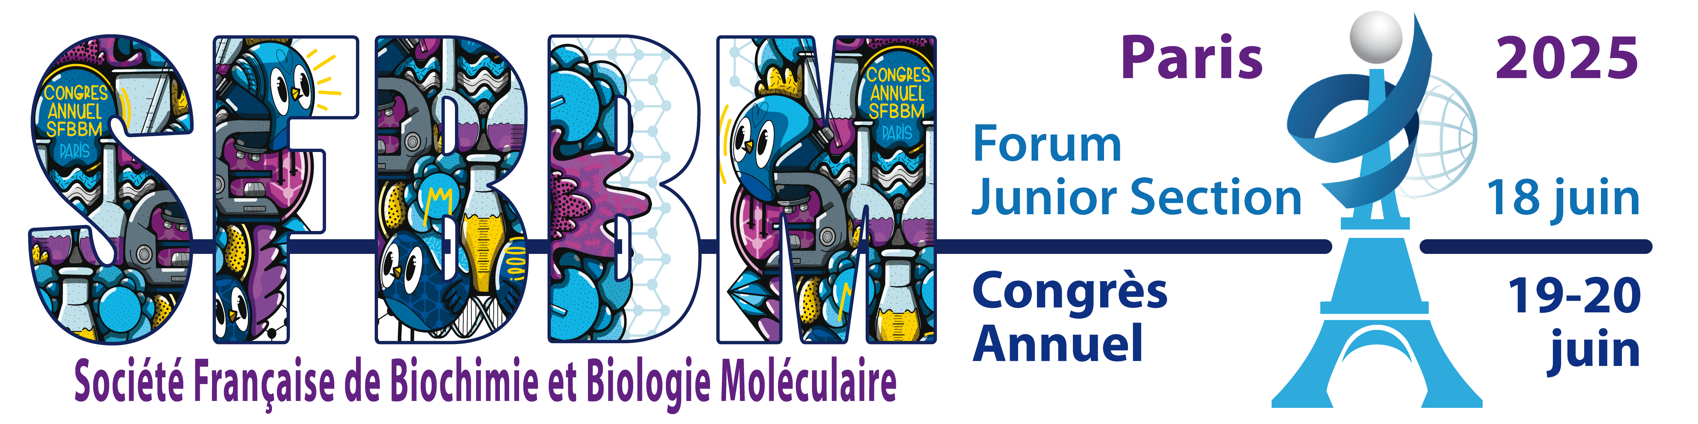

Call for Abstracts

*Guidelines:*

*When submitting abstracts, please note the following guidelines:*

*Body of text: No greater than 250 words (not including subheadings)*

*Title: No greater than 80 characters*

*Do not exceed one page*

*Please also return as Word file by May 12th to : sfbbm@sfbbm.fr*

Template:

**Title**

Author names in the following format:

Anne [first/given name] Smith [last/family name]a, John [first/given name] Doe [last/family name]b

aAffiliation

bAffiliation

E-mail of corresponding author:

Abstract:

Relevant references:

Keywords: Up to 5